**Report on general government budget**

**March 2020**

General government budget recorded a **deficit of RON 18.06 billion (1.67% of GDP) in 2020 Q1** (Annexes 1 and 2).

A larger deficit compared to 2019 Q1 mainly reflects the unfavourable evolution of revenues in March due to deferred payment of taxes during the state of emergency (RON 7.7 billion)[1] and higher VAT reimbursement by RON 3.17 billion in order to support private companies’ liquidity. Furthermore, on the expenditure side, higher investment by RON ~1.0 billion compared 2019 Q1, as well as RON ~1 billion payments in advance for the transitional national aid in the vegetal and zootechnical sector contributed to the increase of the deficit.

1. **general government revenue**

Total revenue amounted to RON 72.23 billion in 2020 Q1, down by 3.3% compared to 2019 Q1, mainly reflecting a contraction in revenues in March (-25.1% yoy) as a result of fiscal facilities implemented to support the economic activity during the state of emergency. However, in March, the total amount of fiscal obligations declared to the National Agency for Fiscal Administration was RON 24.63 billion (+8,5% yoy), but revenues collected were RON 16.95 billion due to deferral of tax payments.

***Personal income tax*** receipts amounted to RON 6.0 billion in 2020 Q1, up by 8.5% yoy. This dynamics was backed by: (i) an increase of 0.7% of the total number of employees and 9.2% of gross wages during Dec ′19-Feb ′20 compared to the same period a year ago and (ii) the increase of minimum wage from RON 2,080 to RON 2,230.

Income tax receipts increased by 10% (yoy) in Jan – Feb 2020 amid accelerating wage bill by 9.4% in February (yoy), but then revenues decreased in March by 9% (yoy) as a consequence of the fiscal measures adopted in the context of the state of emergency[2].

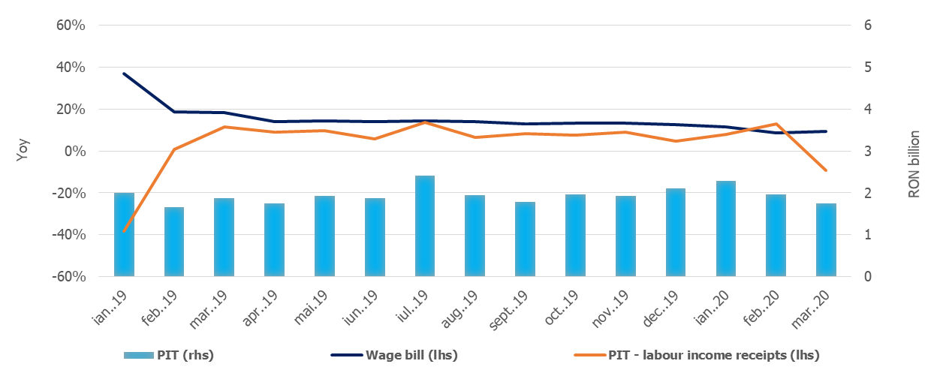

Source: MoPF, NIS, own calculations

**Fig.1 Personal Income Tax Revenue**

***Social contribution revenue*** totalledRON 27.31 billion in 2020 Q1, up by 2% yoy, mainly reflecting the increase of minimum wage and the positive dynamics of the same relevant macroeconomic indicators considered for PIT revenues. In March, the receipts from social contributions were RON 1.7 billion lower than the fiscal obligations declared by taxpayers.

Also, compared to the same period of last year, social contributions revenues were adversely affected by the change in the calculation basis of social security contribution (CAS) and health insurance contribution (CASS) due by part-time employees and the extension from March 15th to May 25th of the submission deadline of the Single Fiscal form for individuals with independent activities.

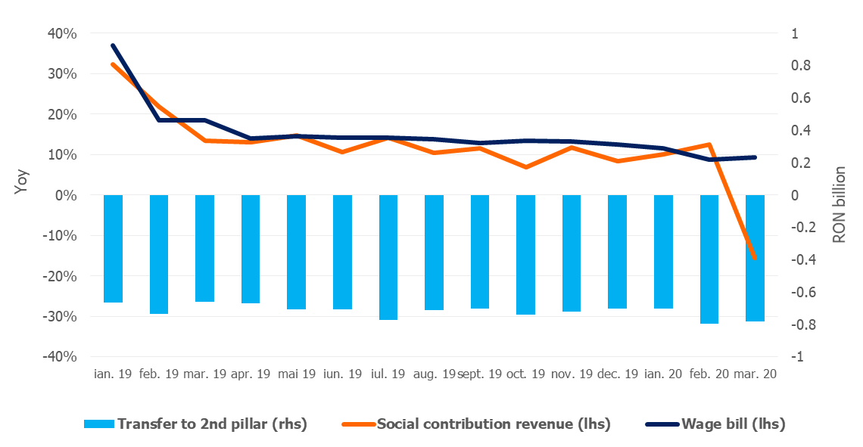

Source: MoPF, NIS, own calculations

**Fig.2 Social contribution revenue**

***Corporate income tax*** revenues amounted to RON 2.86 billion in 2020 Q1, down by 32% (RON -1.35 billion) compared to 2019 Q1, mainly due to tax deferral (GEO no. 29/2020). The structure of CIT revenues underlines a 26.9% reduction of CIT due by companies and a 76.2% reduction of CIT due by commercial banks.

***VAT*** receipts totalled RON 12.29 billion in 2020 Q1, down by 19.4% compared to 2019 Q1, mainly due to significantly lower VAT revenues in March (-82.5%). Although the dynamics of the relevant macroeconomic base (the turnover in trade, services and industry) grew by 12.2%, the net VAT receipts (gross receipts minus reimbursement) have been influenced by higher VAT reimbursement (RON +3.2 billion compared to 2019 Q1)[3] and by the fiscal measures adopted as a consequence of the state of emergency.

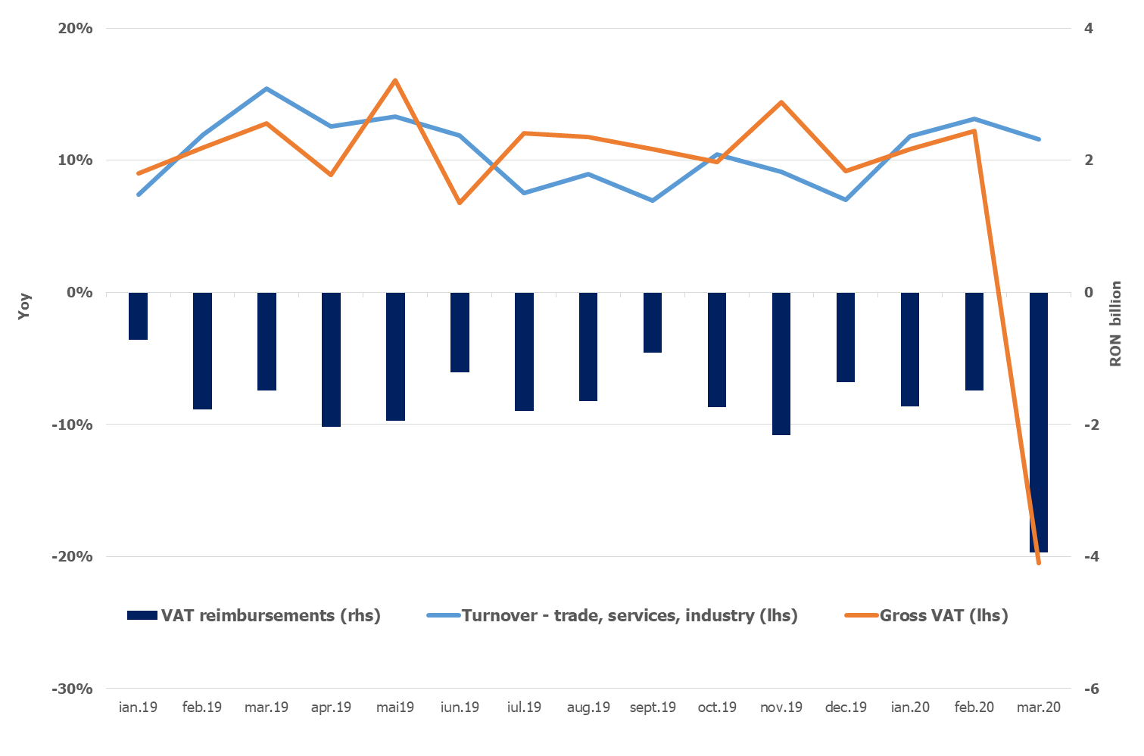

Source: MoPF, NIS, own calculations

**Fig.3 VAT revenue**

***Excise duties*** receipts amounted to RON 7.42 billion in 2020 Q1, up by 8.67% compared to 2019 Q1.

Excise revenue from energy products expanded by 2.2% in 2020 Q1 despite the reduction in excise level on fuel applied since the beginning of the year (by 13% for gasoline and 14.3% for diesel). Excise revenue from tobacco products grew by 15.3% (yoy), supported by a 4.2% hike in the excise level for cigarettes. As expected in the context of the state of emergency, in March, one notes a decline of excise revenue from energy products (-10.9% yoy). Contrariwise, revenues from tobacco products expanded significantly in March (+25.2%, yoy).

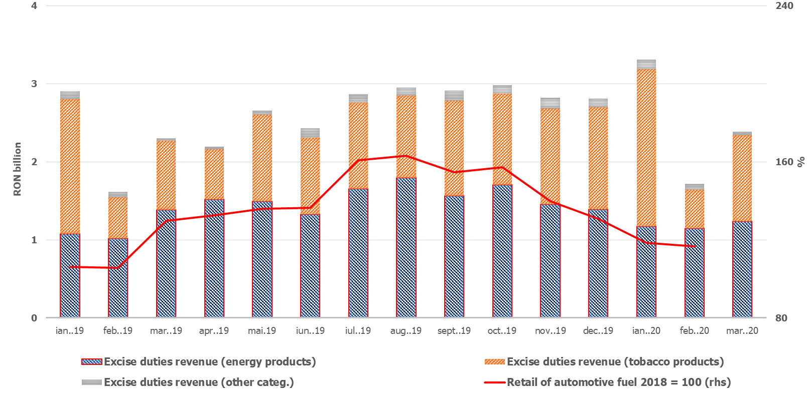

Source: MoPF, NIS, own calculations

**Fig.4 Excise duties revenue**

Revenue from ***taxes on use of goods*** totalled RON 1.68 billion in 2020 Q1 (+28,18% yoy), mainly as a result of revenue collected from broadcast licenses renewal (GD no. 226/2020).

***Non-tax revenue*** amounted to RON 5.50 billion in 2020 Q1, up by 12,86% compared to the corresponding quarter of 2019. Nevertheless, the positive dynamics of non-tax revenues was tamed by lower revenues in March for certain categories[4].

***EU Refunds and donations*** totalled RON 3.9 billion in 2020 Q1, up by 2.2% compared to the first quarter of last year.

1. **GENERAL GOVERNMENT EXPENDITURE**

General government expenditure totalled RON 90.30 billion (8.3% of GDP) in 2020 Q1, advancing by 12.7% compared to 2019 Q1. As a percentage of GDP, total expenditure increased by 0.8 pp, from 7.6% to 8.3%.

***Compensation of employees*** amounted toRON 26.22 billion in 2020 Q1, up by 9.4% compared to the similar quarter of last year, mainly due to public wage hikes (as of Jan 1st , 2019 and Jan 1st , 2020) and introduction of meal allowance to all public sector employees (Law no. 153/2017). As a percentage of GDP, compensation of employees reached 2.4%, reflecting a marginal increase (+0.1 pp).

***Goods and services expenditure*** totalled RON 12.19 billion, advancing by 17.4% compared to the first quarter of 2019. A larger increase was recorded at the local level, as well as for some public institutions entirely or partially self-financed, mainly due to additional payments needed to limit the spread of the Covid-19.

Furthermore, compared to the similar period of last year, a 14% increase was recorded at the level of the Unique National Fund of Health Insurances due to higher payment for drugs and outpatient medical services reimbursements.

***Social assistance expenditure*** reached RON 32.77 billion in 2020 Q1, advancing by 17.0% compared to 2019 Q1. This dynamics is mainly explained by the increase of the pension point by 15% as of September 1st, 2019 (from RON 1,100 to RON 1,265); the increase of the social allowance for pensioners by 10%; of child allowance as of May 1st, 2019, as well as indexing child allowance with the 2019 inflation rate, as of January 1st, 2020. Furthermore, sick leave reimbursements were double compared to 2019 Q1 (RON 401.7 million in March).

***Subsidies*** reached RON 2.62 billion in 2020 Q1, more than 1.6 times higher than in 2019 Q1, largely reflecting subsidies in the agricultural sector during Jan and Feb and payments in advance for the transitional national aid in the vegetal and zootechnic sector.

***Other expenditure*** amounted to RON 1.34 billion (this category includes mainly payment titles issued by the National Authority for Properties Restitution, scholarships for students and payments related to court decisions).

***Expenditure for projects financed from non-reimbursable external funds*** (including EU subsidies for agriculture) reached RON 4.55 billion, 8.1% above the level recorded in 2019 Q1.

***Investment***, which includes capital expenditure and spending related to development programs financed from domestic and external sources, totalled RON 5.85 billion, 20.4% higher than in 2019 Q1, reflecting increases at both central and local level, financed from both domestic and non-reimbursable external funds. Additionally, in March, RON 154.7 million were paid from the budget of the Ministry of Internal Affairs for emergency medical products (including thermal scanners) to limit the spread of the Coronavirus.

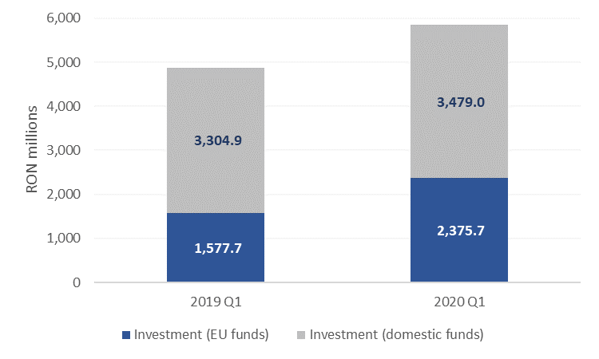

Source: MoPF

**Fig. 5 Public investment structure**







1. Fiscal facility granted through GEO no. 29/2020 regarding certain economic and fiscal measures to support private companies. According to GEO no. 29/2020, no late payment interest and penalties shall be owed for the tax liabilities outstanding as of the date of entry into force of GEO no. 29/2020 and not paid within 30 days as of the termination of the state of emergency.
2. GEO no. 29/2020 and the extension of the deadline for submission of the Single Fiscal form for individuals with independent activities from March 15th to May 25th (income tax and compulsory social contributions).
3. In March, VAT reimbursement amounted to RON 3.94 billion (RON 7.15 billion in 2020 Q1 compared to RON 3.98 billion in 2019 Q1) with the aim to support the liquidity of private companies during the state of emergency.
4. GEO no. 34/2020 states that the validity of documents issued by public authorities which expire during the state of emergency is maintained. This measure generates a reduction for a range of revenues from different public services, fees for issuing documents, etc.