Report on general government budget
2019

Based on operational data, general government budget in 2019 registered a RON 48.3 billion deficit of (4.6% of GDP) (Annexes 1 and 2). The general government budget outcome for 2019 indicates a widening by 1.8 pp in GDP in budget deficit, from 2.8% of GDP in 2018.

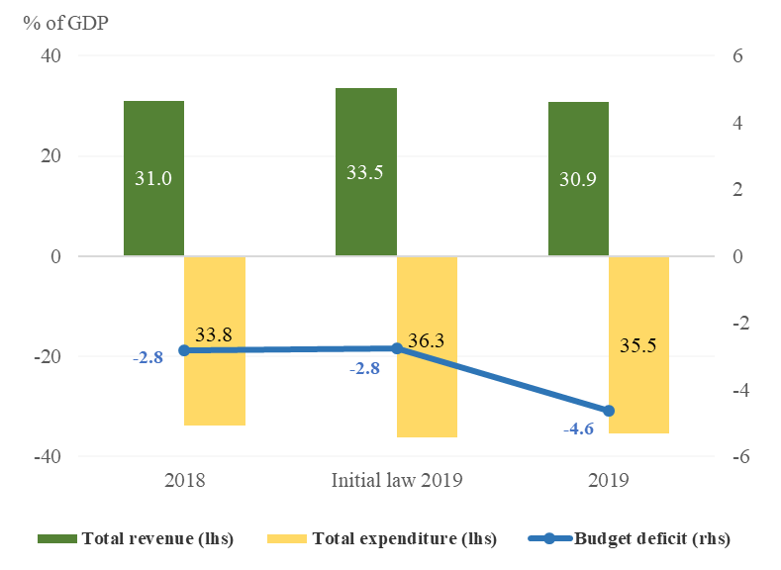
Source: MoPF, own calculations
Fig.1 Budget deficit

- general government revenue

Total revenue amounted to RON 321.13 billion, 8.8% above the level recorded in 2018. Compared to the initial target provided by the annual budget law, general government revenue was RON 21.5 billion lower (93.7%), out of which RON 8.4 billion from EU funds, RON 6.1 billion from tax revenue, RON 5.8 billion from social contributions, and RON 1.2 billion from non-tax revenue.
However, as a share of GDP, the budget revenue registered only a marginal decrease (0.1 pp) from 31.0% of GDP in 2018 to 30.9% of GDP in 2019. The decline was mainly due to a reduction of non-tax revenue (0.3 pp) and EU funds (0.4 pp), whereas tax revenue stood at 15% of GDP in 2019, and social contributions receipts advanced by 0.4 pp of GDP.

Corporate income tax revenue amounted to RON 17.72 billion in 2019, up 13.2% from 2018, mainly driven by a 70% increase of the CIT revenue due by the banking sector. CIT receipts rose in December by 28.4% (yoy), faster than the pace reached over the first 11 months of the year. This performance brought the annual receipts above the initial target (by RON 0.53 billion or 103.1%).
Personal income tax receipts recorded RON 23.20 billion in 2019, up 2.3% compared to 2018 (but decreasing as a share of GDP, from 2.4% in 2018 to 2.2% in 2019). Annual dynamics mainly reflected a statistical base effect in January 2019 compared to January 2018 due to social contributions transfer from employers to employees and to a lower PIT rate (from 16% to 10% according to GEO no.79/2017, impact of RON 1.2 billion). Compared to the initial target, PIT revenue was RON 0.46 billion lower (98%). Labour income tax receipts account for 80% of PIT. Annual dynamics of the labour income tax receipts mainly reflects the overall economy's wage bill developments (gross average earning increased by 14.7% and the average number of employees by 1% over the reference period). Nevertheless, exempting the employees from construction and some industrial sectors (according to GEO no. 114/2018) from the labour income tax lowered the annual revenue by RON 1.1 billion.
Furthermore, amounts related to Single Tax Statement submitted by taxpayers and some other adjustments incurred in December 2018 adversely affected PIT receipts dynamics in December 2019.
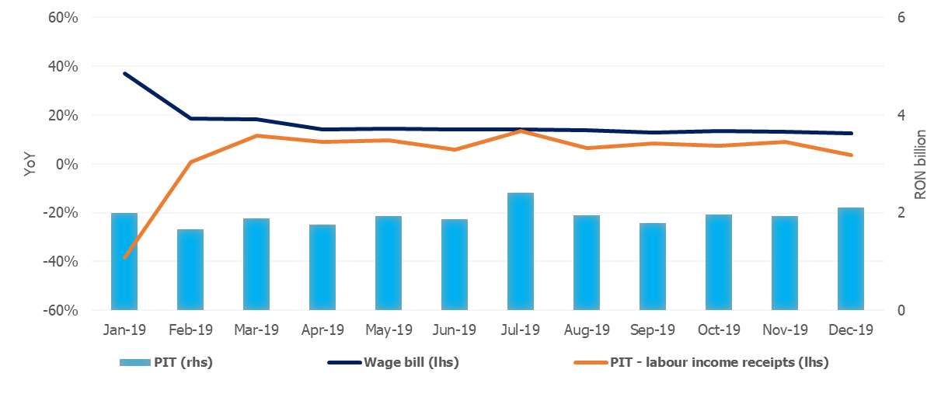
Source: MoPF, NIS, own calculations
Fig.2 Personal income tax revenue

Social contributions revenue recorded RON 111.47 billion in 2019, 13.6% higher than 2018 level (from 10.3% of GDP in 2018 to 10.7% of GDP in 2019). Compared to the initial planning, revenue was RON 5.77 billion lower (95.1%). Similar to PIT receipts, social contributions revenue is in line with developments in the overall economy's wage bill (16% since December 2018 to November 2019). In the fourth quarter social contributions receipts reflects the easing in wage dynamics. Furthermore, the receipts dynamics was adversely affected by exempting the employees from construction and some industrial sectors from the health insurance contribution, as well as by reducing the social contributions due by employers (according to GEO no.114/2018, with a negative impact of RON 1.6 billion) and, to a lesser extent, by transfers to the second pillar pension fund (RON 8.5 billion in 2019).
In addition, social contributions transfer from the employer to the employee according to GEO no. 79/2017 brought a significant increase in revenue in January 2019 compared to January 2018 (significant base effect). Monthly dynamics of social contributions revenue steadily slowed down to a minimum level in October, but flattened over November-December at an average of 10.1% (yoy).
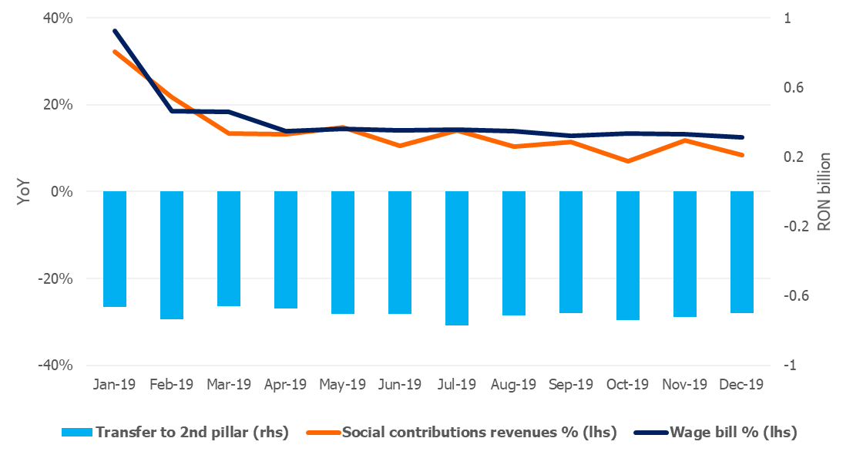
Source: MoPF, NIS, own calculations
Fig.3 Social contribution revenue

Excise duties receipts amounted to RON 31.46 billion in 2019, up 10.3% from the previous year's revenue. Compared to the initial target, revenue was RON 0.39 billion higher (101.3%), mainly reflecting a 16% (yoy) increase in revenue in December. As a share of GDP, excise revenue stood at 3.0% in 2019, with energy products and tobacco excises accounting for 96.5% of all.
Compared to 2018, excise revenue from energy products grew by 6.4%, due to a 3.1% hike level for fuels and a 7% rise in fuels consumption. Excise revenue from tobacco products was 17.7% larger compared to 2018, mainly reflecting an 8% increase in excise duty level for cigarettes.
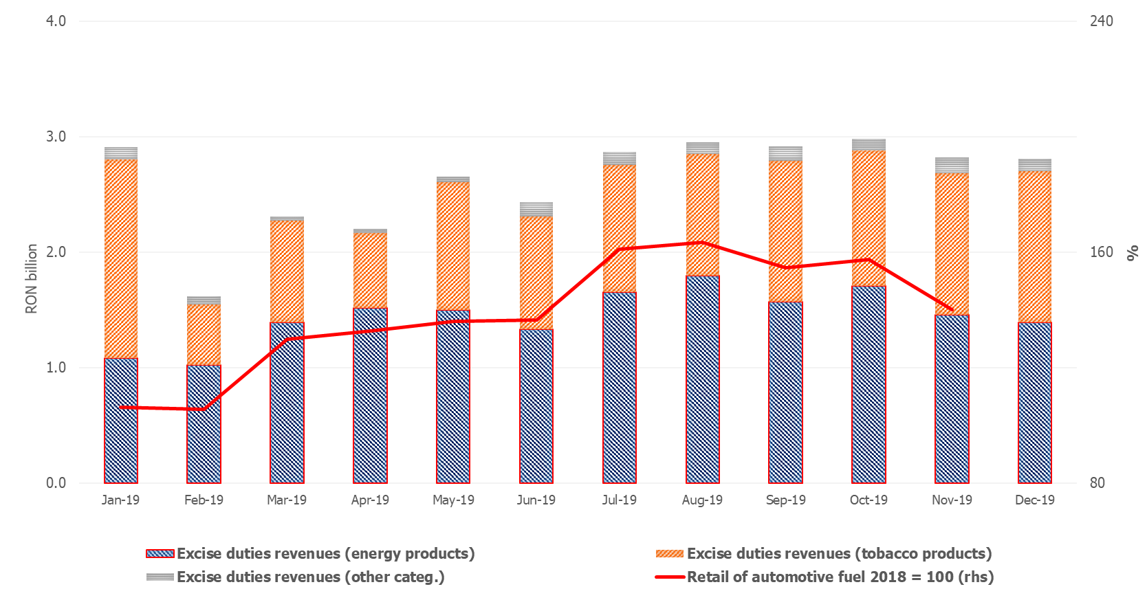
Source: MoPF, NIS, own calculations
Fig.4 Excise duties revenue

VAT receipts amounted to RON 65.42 billion in 2019, up 9.7% compared to 2018. As a share of GDP, VAT revenue stood at 6.3% in 2019. Compared to the initial target, the revenue was RON 4.23 billion lower (93.9%). VAT receipts rose by 8.1% (yoy) in December, faster than the relevant macroeconomic base (turnover in trade, services and industry).

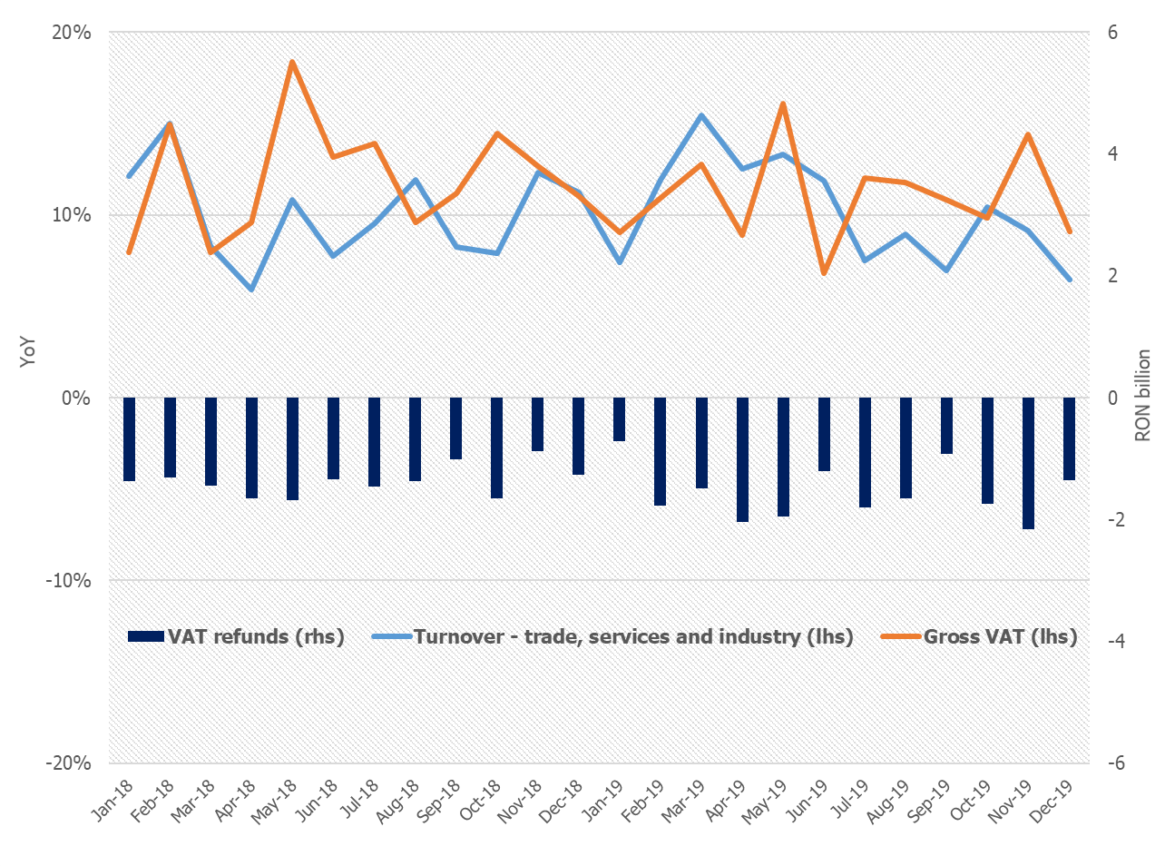
Source: MoPF, NIS, own calculations
Fig.5 VAT revenue

In 2019, gross VAT revenue (excluding refunds) increased by 11% yoy, whereas VAT refunds rose by 14.5% (RON 18.8 billion in 2019), while the relevant macroeconomic base grew on average by 10.4% in 2019. Furthermore, 2019 VAT receipts dynamics was adversely affected by the broadening of the 5% reduced VAT rate to restaurant and catering services, high quality food deliveries, hotel accommodation services (from 9%).
Revenue from taxes on use of goods decreased by RON 0.27 billion compared to 2018, mainly due to RON 3.0 billion refunds of environment stamp duty for cars collected in previous years (in 2018 were refunded RON 1.6 billion). Gambling tax revenue increased by an annual 25.7% pace in 2019. However, revenue from taxes on the use of goods were RON 3.5 billion lower compared to the initial target, mainly due to postponed 5G frequencies sale.
Non-tax revenue totalled RON 27.09 billion in 2019 (-0.4% yoy) and RON 1.20 billion lower compared to the initial target (95,8%). Revenue from SOEs dividends and payments from the autonomous administrations net profit was RON 5.97 billion in 2019, 20% lower than the 2018 receipts, as a result of lower additional dividends by RON 1.3 billion in December, according to GEO no.114/2018. Non-tax revenue to the state budget (from concessions, interest, services and other activities, administrative and licenses fees, penalties and confiscations) increased by 15.1% compared to 2018.
When excluding RON 3.8 billion EU refunds from retrospective, EU Refunds and donations amounted to RON 25.32 billion in 2019 (2.4% of GDP), slightly higher than in 2018, but 0.8 pp of GDP behind the initial target.

- general government expenditure

General government expenditure amounted to RON 369.43 billion (35.5% of GDP), up 14.7% compared to the previous year, but marginally lower compared to the initial target (99.6%). Total expenditure increased by 1.7 pp, from 33.8% of GDP in 2018 to 35.5% of GDP in 2019.
The expansion of budget expenditure is explained by the increase, as a share of GDP, of compensation of employees by 0.8 pp, social assistance by 0.4 pp, investment by 0.6 pp and goods and services by 0.4 pp.

Compensation of employees grew by 18,8% (yoy) in 2019, to RON 102.34 billion, in line with the initial target. As a share of GDP, compensation of employees increased by 0.8 pp, from 9% in 2018 to 9.8% in 2019. This dynamics is mainly explained by the hikes in public wages (according to Law 153/2017) and in minimum wage. This amount also includes wage settlements for state universities personnel stipulated by Law 85/2016 - 2018 arrears and payments corresponding to 2019, as well as settlements as to court decisions related to wage rights in education and justice (impact of RON 1.7 billion).
Goods and services expenditure amounted to RON 52.78 billion (18.3%, yoy), RON 4 billion above the initial target, due to additional spending for drugs and overdue invoices in local public administration.
Interest expenditure amounted to RON 12.15 billion, 6,1% lower compared to 2018 and RON 1.26 billion below the initial target.
Subsidies amounted to RON 7.11 billion and stood at 0.7% of GDP.
Social assistance expenditure amounted to RON 114.74 billion, up 13.2% (yoy). This dynamics is mainly explained by increases in: (i) pension point by 10% as of July 1st, 2018 (to RON 1,100) and by 15% since September 1st, 2019 (to RON 1,265); (ii) social allowance for pensioners as of July 1st, 2018 and September 1st 2019 (from RON 520 to RON 640 and subsequently to RON 704) and (iii) child allowances. Compared to the initial target, social assistance (pensions, child allowances, disability allowances, maternity allowances etc.) were RON 5.2 billion higher. RON 1.2 billion correspond to overdue health insurance payments on medical leave.
Other expenditure (mainly amounts related to the payment titles issued by the National Authority for Properties Restitution according to legislation in force, scholarships for students and civil damages) amounted to RON 7.62 billion in 2019, RON 1.5 billion above the initial target. This increase also includes the settlement of RON 0.91 billion in December as to arbitration decision issued by the International Centre for Settlement of Investment Dispute (Arbitration File no. ARB / 05/20).
Investment, which include capital expenditure, as well as spending related to development programs financed from domestic and external sources, amounted to RON 43.61 billion (4.2% of GDP). The 27.4% annual increase was mainly driven by the settlement of invoices issued over the last two months (RON 16.8 billion, representing 38.5% of total annual investments) for the investment projects in central and local administration (bringing the final capital expenditure RON 4.95 billion above initial target).
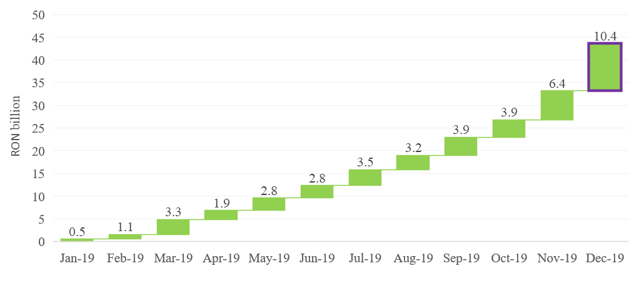
Source: MoPF, own calculations
Fig. 6 Public investment spending
On the other hand, expenditure for projects financed from non-reimbursable external funds (including EU subsidies for agriculture) amounted to RON 27.99 billion, RON 10.43 billion lower than the initial target. A slow implementation of projects financed from EU funds was also reflected on the revenue side (0.8 pp of GDP lower the initial target).
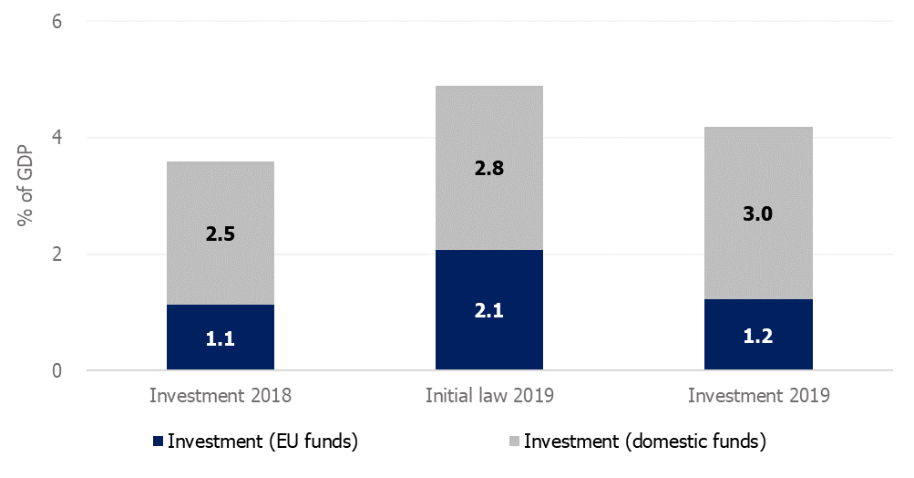
Source: MoPF, own calculations
Fig. 7 Public investment structure

- budget deficit – comparison to targets
The sharp deterioration of budget deficit in 2019 compared to the 2,76% of GDP target was due to planned increase of certain expenditure categories, in line to the annual budget law approved at the beginning of 2019, not offset by a corresponding revenue increase or substantial savings in other spending items.

Compared to 2018, the significant exceeding of programmed budget expenditure by 2.5 pp of GDP, directed in particular towards the increases of (i) investments (1.29 pp, to 4.89% of GDP in 2019) and (ii) compensation of employees (1.0 pp, to 10% of GDP in 2019), was projected to be covered by a broad increase in budget revenue (by 2.5 pp of GDP). However, the projected increase in budget revenue through improving tax collection (0.9 pp), increasing social contribution revenue (1.2 pp) and EU funds (0.4 pp) proved to be based on sources with a high degree of uncertainty and did not materialize to a large extent.
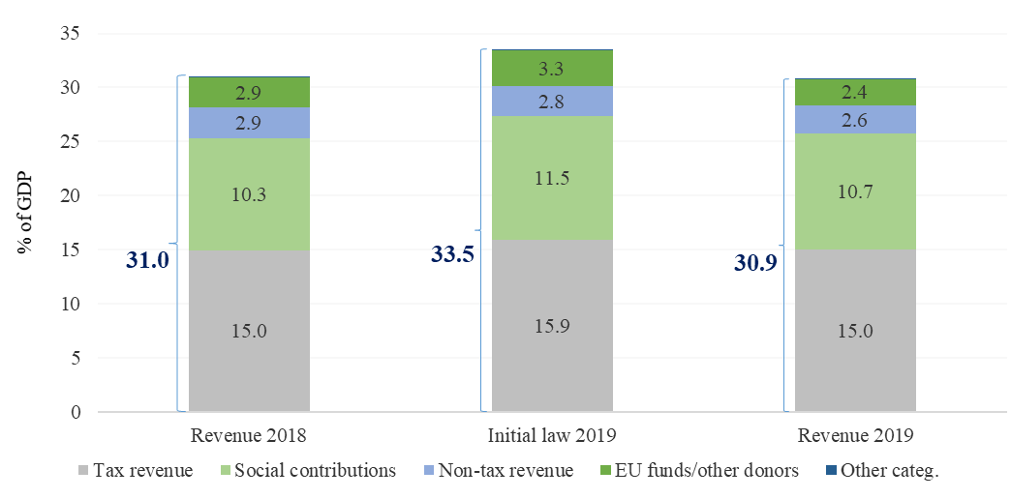
Source: MoPF, own calculations
Fig.8 Budget revenue
Thus, total revenue was 2.7 pp of GDP lower than the initial target, out of which 0.9 pp from tax revenue, 0.8 pp from social contributions and 0,9 pp from EU funds received. At the same time, total expenditure reached a nominal level close to the initial target (only RON 1 billion lower than targeted), given that initial underestimation of social assistance spending (0.3 pp of GDP - pensions, child allowance, disabilities allowance, parental benefits) and goods and services expenditure (0.3 pp of GDP) were offset by lower than targeted investment (0.7 pp of GDP).
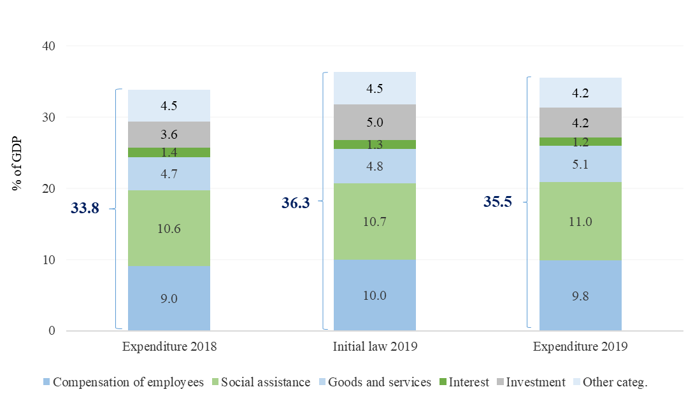
Source: MoPF, own calculations
Fig.9 Budget expenditure
Compared to the second budget rectification target (4,4% of GDP), the budget deficit expanded more than projected (+0.2 pp of GDP), due to:
- lower additional dividends by RON 1.3 billion from SOEs, according to GEO no.114/2018, as such payment would have adversely affected the investment capacity of these companies.
- RON 0.91 billion settlement from the budget reserve fund as to the arbitration decision issued by the International Centre for Settlement of Investment Dispute (file no. ARB/05/20).
- additional payments incurred in administrative-territorial units, well above the dynamics in December 2018 or Jan-Nov 2019 average (RON 1.3 billion impact in December 2019).

Share in GDP has changed following the revision of the 2018 GDP and estimated GDP in 2019
The differences between total data and the sum of components are due to rounding
PIT revenue includes tax receipts from labour income, capital income and other sources (mostly pensions)
During Nov-Dec VAT refunds increased by 64% compared to the same period in 2018.
EU refunds for projects financed from the national budget between 2014-2018, which were retrospectively considered eligible by the European Commission

