Report on general government budget
June 2020

General government budget recorded a deficit of RON 45.17 billion (4.17% of GDP) in 2020 H1.
More than half of the deficit, namely RON 23.04 billion (2.13% of GDP) corresponds to fiscal facilities – amounts left in the economy to support private companies’ liquidity, and exceptional spending required to limit the spread of the virus (Annexes 1 and 2).
A larger deficit compared to the similar period of last year is mainly explained, on the revenues side, by (i) the unfavourable total revenues’ dynamics during March - May as a consequence of payment deferral during the state of emergency (RON 10.2 billion), (ii) higher VAT reimbursement to support private companies’ liquidity (RON +2.94 billion compared to 2019 H1), (iii) discounts applied on CIT and taxes on micro-enterprises’ revenues (RON 0.25 billion).
On the expenditure side, beside the increase resulted from applying the current legislation, investment rose by RON 3.79 billion compared to 2019 H1, while exceptional Covid-19 related payments totalled RON ~5.86 billion.

- general government revenue

Total revenue amounted to RON 146.25 billion in 2020 H1, down by 1.6% compared to the corresponding period of last year. As a percentage of GDP forecast, the total revenues decreased by 0.5 pp, mainly due to a contraction of net VAT receipts (higher VAT reimbursement and payment deferral) and a decline of non-tax revenues.
In regards to the monthly dynamics, after a significant advance reached over the first two months of the year, starting from March, total revenues recorded in general an unfavourable evolution - increased uncertainty, restrictions and suspension of certain activities amid the current health crisis, which led to the postponement of tax obligations given also the facilities provided to taxpayers. However, in June, when certain fiscal obligations reached the deadline, total revenues recorded a significant increase (+ 7.4%, yoy), largely backed by CIT, PIT, property taxes, and social contributions receipts.

Personal income tax revenue totalled RON 12.22 billion in 2020 H1, advancing by 10.4% (yoy).
Single Declaration related revenues counted for the largest contribution to PIT dynamics (RON +0.8 billion compared to 2019 H1). However, this evolution is explained by different deadlines: 31st of July in 2019 versus 30th of June in 2020.
Furthermore, the PIT receipts’ evolution was backed by higher revenues from pensions (+40.8% yoy) and dividends (+16.9% yoy).
While the wage bill expanded by 6.1% over Dec’19 – Apr’20 (yoy), the main component - labour income tax receipts increased only marginally in 2020 H1 (+0.9% yoy) due to payment deferral (GEO no. 29/2020, respectively GEO no. 90/2020). Nevertheless, labour income tax receipts registered a significant increase in June (+8.7% yoy).
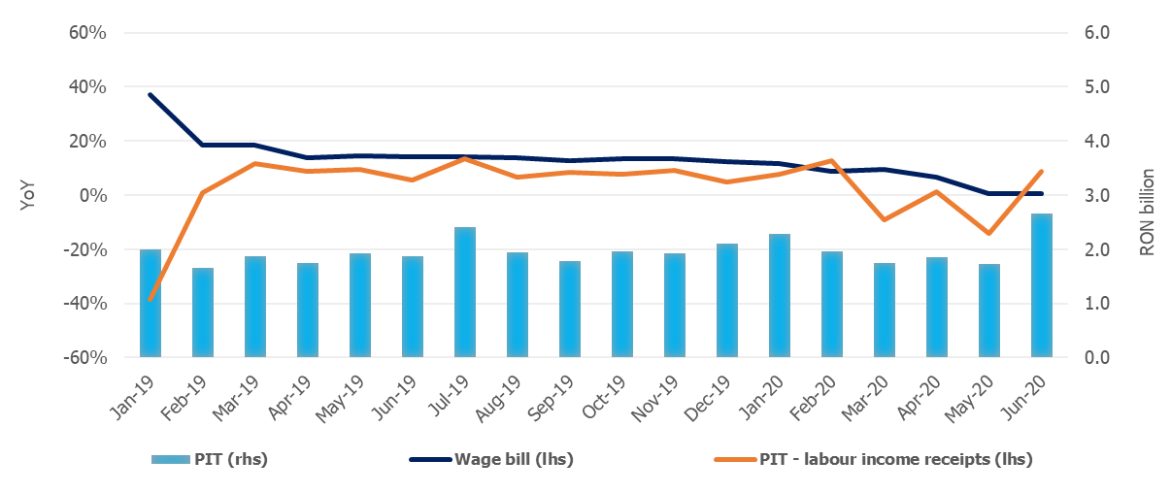

Source: MoPF, NIS, own calculations
Fig.1 Personal Income Tax Revenue
Social contribution revenue totalled RON 54.84 billion in 2020 H1. Despite a positive evolution in June (+10.8%, yoy), the cumulative figure for H1 underlines just a stagnation (+0.04%, yoy).
Social contributions revenues were adversely affected by (i) payment deferral, (ii) the change in the calculation basis of social security contribution (CAS) and health insurance contribution (CASS) due by part-time employees, and (iii) exemption from work insurance contribution (CAM) payment for temporary laid-off employees.

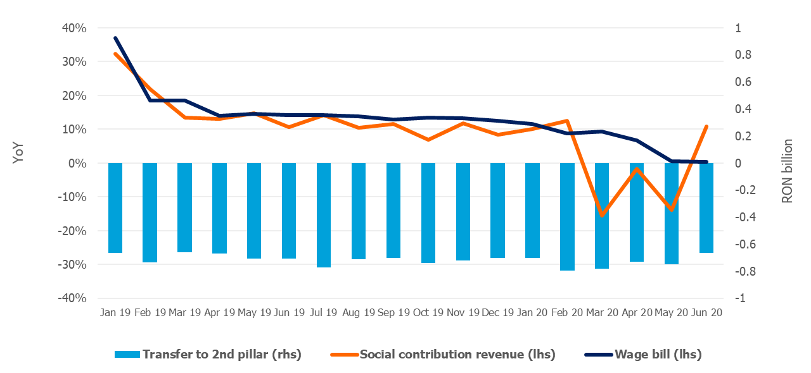

Source: MoPF, NIS, own calculations

Fig.2 Social contribution revenue
Corporate income tax revenue amounted to RON 7.53 billion in 2020 H1, down by 7.5% compared to 2019 H1. The negative dynamics is largely explained by payment deferral (GEO no. 29/2020), as well as by discounts offered to CIT taxpayers who paid the tax owed: 5% for large taxpayers and 10% for small and medium taxpayers (GEO no. 33/2020, total impact of RON 0.22 billion).
Other taxes on income, profit and capital gains from juridical persons amounted to RON 1.58 billion in the first half of the year, declining by 8.5% (yoy), mainly due to payment deferral for micro-enterprises revenues taxpayers (GEO no. 29/2020), and a 10% discount offered to those who paid the tax owed (GEO no. 33/2020, total impact of RON 0.03 billion).
VAT receipts amounted to RON 25.39 billion in 2020 H1, declining by 15.8% compared to the similar period of last year.
Over the first half of the year, the VAT revenues dynamics was negatively influenced by: (i) higher VAT reimbursement by 32.1% (yoy) in order to provide additional liquidity to private companies during the economic downturn, (ii) tax deferral, and (iii) unfavourable evolution of the economic activity since March.
Whilst the gross VAT receipts grew significantly in June (+9.9%, yoy), due to higher VAT reimbursement (+56% compared to June 2019), net VAT receipts decreased by 1.2% (yoy).
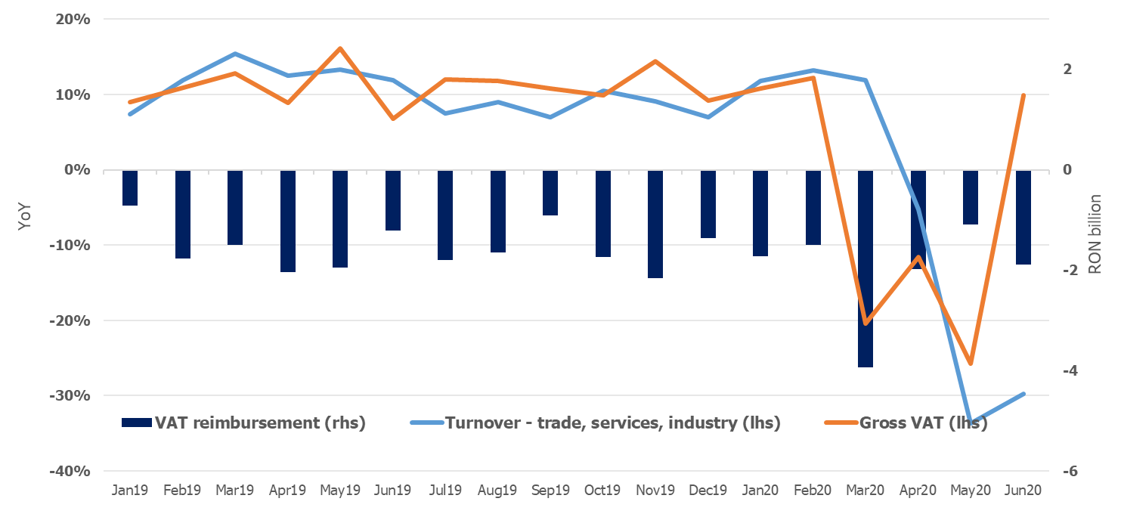
Source: MoPF, NIS, own calculations
Fig.3 VAT revenue
Excise duties receipts totalled RON 13.64 billion in 2020 H1, decreasing by 3.3% compared to the similar period of last year.
Over the first half of the year, excise revenue from energy products decreased by 15.1% (yoy), mainly due to a decline of fuel consumption since March amid the current economic crisis. Conversely, excise revenue from tobacco products grew by 11.2% (yoy), backed also by a 4.2% hike in the excise level for cigarettes.
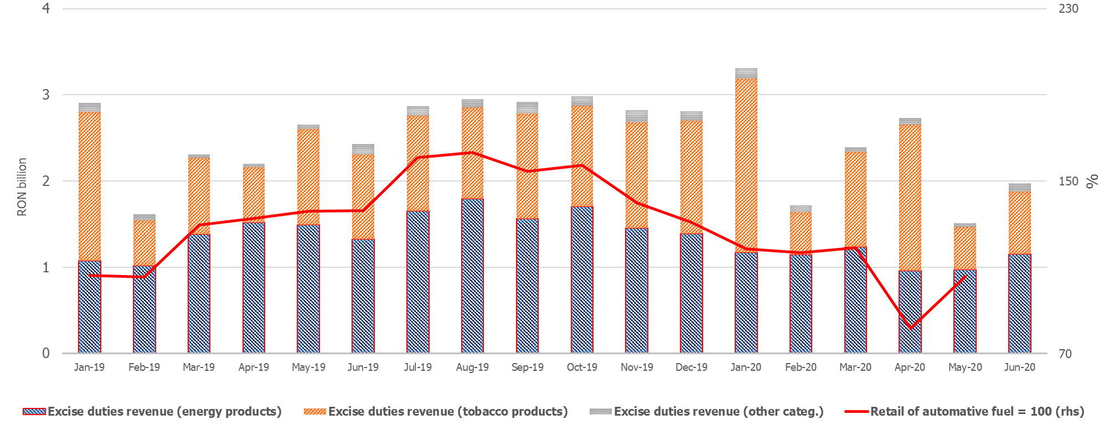

Source: MoPF, NIS, own calculations
Fig.4 Excise duties revenue
Revenue from taxes on use of goods totalled RON 2.07 billion 2020 H1. Although it recorded a significant increase compared to the similar period of last year, this dynamics is mainly explained by a negative base effect – in 2019 there were refunded environmental car stamp duties collected over the previous years. In addition, the positive dynamics was also backed by ANCOM’s revenues collected for broadcast licenses renewal.
Conversely, revenues from gambling taxes declined by 31.2% (yoy) due to payment exemption for gambling authorizations during the state of emergency (GEO no. 48/2020) and tax deferral.
Non-tax revenues amounted to RON 11.73 billion in 2020 H1, declining by 12.1% compared to the similar period of last year. The unfavourable dynamics is largely explained by lower revenues from dividends (RON -1.2 billion) due to a two-months delay in submitting the 2019 annual financial statements (until 31st of July 2020).
EU refunds and donations totalled RON 8.98 billion in 2020 H1, advancing by 18.1% (yoy).
- GENERAL GOVERNMENT EXPENDITURE

General government expenditure totalled RON 191.43 billion in 2020 H1, advancing by 13.6% compared to the corresponding period of the previous year. As a percentage of GDP forecast, total expenditure increased by 1.8 pp, from 15.9% in 2019 H1 to 17.7% in 2020 H1. This increase is also explained by the measures adopted to limit the spread of the virus, and on the other hand, by discretionary measures adopted in order to mitigate the negative impact on the economic activity.
Thus, RON 3.69 billion were paid in 2020 H1 for technical unemployment benefits, RON 744 million for other categories of professionals and for those with an individual employment agreement that were forced to stop their activity in the context of the state of emergency, and RON 36.2 million for allowances to parents in order to supervise their children during the temporary closure of educational institutions.

Compensation of employees totalled RON 53.3 billion, up by 4.5% compared to the same period of last year, reflecting public wage hikes and introduction of meal allowance to all public employees as of January 1st, 2019 (Law no. 153/2017), but also by another round of public wages hikes as of January 1st, 2020. As a percentage of GDP forecast, compensation of employees represented 4.9%, increasing only marginally compared to 2019 H1 (+0.1pp). In addition, RON 178.7 million were paid in June to award bonuses to the medical staff treating Covid-19 patients.
Goods and services expenditure amounted to RON 25.36 billion, advancing by 16% compared to 2019 H1 (+16.1% for local budgets level, and +12,6% for some public institutions entirely or partially self-financed), mainly due to additional payments for drugs, sanitary materials and other products needed to test and to treat the people infected with Coronavirus.
Furthermore, compared to the similar period of last year, a 13.6% increase was recorded at the level of the Unique National Fund of Health Insurances due to higher payments for drugs and outpatient medical services reimbursements.
Social assistance expenditure reached RON 69.22 billion, up by 23.7% compared to the similar period of last year. This evolution is mainly explained by a 15% increase of the pension point as of September 1st, 2019 (from RON 1,100 to RON 1,265); a 10% increase of the social allowance for pensioners; an increase of child allowance as of May 1st, 2019, as well as indexing child allowance to 2019 inflation rate as of January 1st, 2020.
At the same time, since April, additional payments have been made to offset the negative impact of the Coronavirus outbreak: temporary unemployment benefits (RON 3.69 billion) and unemployment benefits for other categories of professionals and for those with an individual employment agreement that were forced to stop their activity due to the pandemic (RON 744 million). Furthermore, the sick leave reimbursements continue to be repaid at an accelerated pace (RON 548.6 million in June), in order to reduce the stock of outstanding payments.
Subsidies reached RON 3.88 billion, the largest part being allocated to the agricultural and transportation sectors, i.e. subsidies to support agricultural producers, passengers’ transportation, and for price - tariff differences.
Other expenditure amounted to RON 2.99 billion, representing mainly amounts related to payment titles issued by the National Authority for Properties Restitution, scholarships for students and payments related to court decisions, as well as allowances paid to parents in order to supervise their children during the temporary closure of educational institutions (RON 36.2 million).
Expenditure for projects financed from non-reimbursable external funds (including EU subsidies for agriculture) totalled RON 10.37 billion, up by 20.3% compared to 2019 H1.
Investment, which includes capital expenditure and spending related to development programs financed from domestic and external sources, amounted to RON 16.12 billion in H1, recording the peak of the last 10 years (for the cumulative six months’ period). Compared to 2019 H1, investment grew by 30.8% (reflecting increases at both central and local level, financed from both domestic and non-reimbursable external funds).
Furthermore, RON 266.16 million were paid from the budget of the Ministry of Internal Affair for the purchase of emergency medical products, including thermal scanners, in order to limit the spread of the Coronavirus.
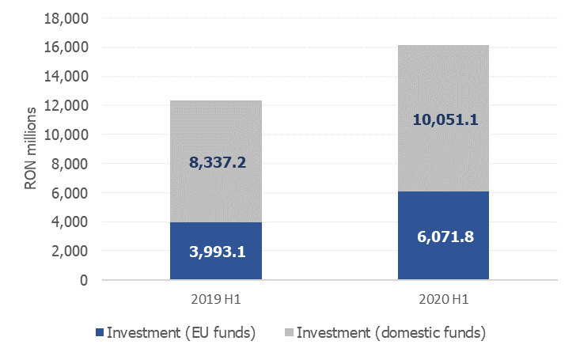
Source: MoPF
Fig. 5 Public investment structure

GEO no. 29/2020, respectively GEO no. 90/2020.
30th of June 2020 was the deadline for the taxpayers to submit the Single Fiscal Declaration, as well as for property tax payment (buildings, lands, and motor vehicles).
GEO no. 69/2020
Labour income tax receipts accounts for ~80% of total PIT revenues.
GEO no. 30/2020
Taxes on micro-enterprises revenues represent ~99% of the category other taxes on income, profit and capital gains from juridical persons.
GD no. 226/2020 regarding the establishment of fees due for the extension of radio frequencies licenses, and payment conditions.

