Report on general government budget
30 SEPTEMBER 2020

General government budget recorded a deficit of RON 67.27 billion (6.36% of GDP) in the first nine months of 2020, out of which more than half is the result of the measures to combat the crisis caused by the COVID-19 epidemic.
Part of the deficit, namely RON 37.12 billion (3.51% of GDP) corresponds to fiscal facilities – amounts left in the economy to support private companies’ liquidity, and exceptional spending required to limit the spread of the virus (Annexes 1 and 2).
A larger deficit compared to the similar period of last year is mainly explained, on the revenues side, by (i) the unfavourable total revenues’ dynamics during March - September due to the economic downturn, but also as a consequence of payment deferral during the state of emergency (RON 16.15 billion), (ii) higher VAT reimbursement to support private companies’ liquidity (RON +3.22 billion compared to the first nine months of 2019), (iii) discounts applied on CIT and on micro-enterprises’ revenues tax (RON 0.57 billion).
On the expenditure side, beside the increase resulted from applying the current legislation, investment rose by RON 6.83 billion compared to the first nine months of 2019, while exceptional Covid-19 related payments totalled RON ~10.35 billion.

- general government revenue

Total revenue amounted to RON 227.72 billion in the first nine months of 2020, down by 0.4% compared to the similar period of last year. As a percentage of GDP forecast, the total revenues decreased by 0.05 pp, mainly due to a contraction of net VAT receipts.
Regarding the monthly evolution, the dynamics of total revenues in September remain in the positive territory (7.6% yoy), driven mainly by the advance of European funds, non-tax revenues and social contributions. In addition, the increased volatility of monthly receipts, since March, is explained by the tax facilities granted in the current context.
Personal income tax revenue totalled RON 18.08 billion in the first nine months of 2020, advancing by 5.1% (yoy). Pensions related revenues (+41.4% compared to the first nine months of 2019) counted for the largest contribution to PIT dynamics. Furthermore, the PIT receipts’ evolution was backed by higher revenues related to the Single Declaration (+19% yoy) and dividends (+12.2% yoy).
While the wage bill expanded by 5.6% over Dec’19 – Aug’20 (yoy), the main component - labour income tax receipts increased in the first nine months of 2020 (+1,1%, yoy) due to payment deferral. However, PIT revenues accelerated in September (+ 5.3% yoy), converging towards the evolution of the relevant macroeconomic base (Fig 1).

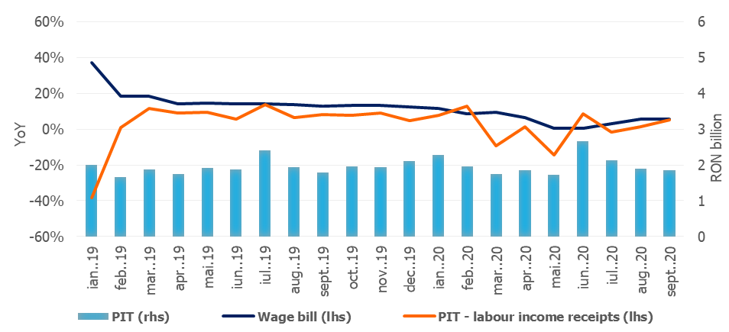

Source: MoPF, NIS, own calculations
Fig.1 Personal Income Tax Revenue
Social contribution revenue totalled RON 82.92 billion in the first nine months of 2020,
similar to the level recorded in the same period of the last year. However, the monthly evolution reflects a recovery of social contributions receipts in September (+2.7% yoy), while the wage bill increased by 5.6% (Fig. 2).
Social contributions were adversely affected by (i) payment deferral, (ii) the change in the calculation basis of social security contribution (CAS) and health insurance contribution (CASS) due by part-time employees, and (iii) the exemption from work insurance contribution (CAM) payment for temporary laid-off employees.
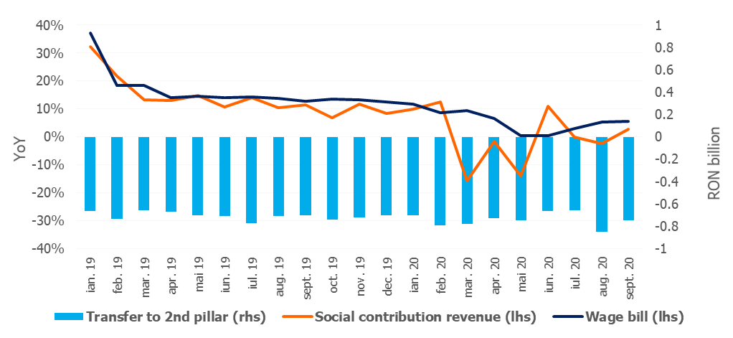
Source: MoPF, NIS, own calculations

Fig.2 Social contribution revenue
Corporate income tax revenue amounted to RON 10.81 billion in the first three quarters of 2020, down by 13.8% compared to the similar period of last year (the CIT revenue recording however a positive dynamic in September, +28.1% yoy). The structure of CIT revenue underlines a 9.3% reduction of CIT due by companies and a 51.5% reduction of CIT due by commercial banks.
The unfavourable dynamics is explained by the contraction of the economic activity, payment deferral, as well as by discounts offered to CIT taxpayers: 5% for large taxpayers and 10% for small and medium taxpayers (GEO no. 33/2020, total impact of RON 0.57 billion).
Other taxes on income, profit and capital gains from legal persons amounted to RON 2.3 billion in the first nine months of the year, declining by 17.2% (yoy). Likewise, this evolution is explained by the payment deferral for micro-enterprises revenues, and a 10% discount offered to those who paid the tax owed (GEO no. 33/2020).
VAT receipts amounted to RON 40.72 billion in the first nine months of 2020, declining by 14.3% compared to the similar period of last year. Given the economic rebound in trade sector, the negative dynamics of gross VAT revenue continues to ameliorate in September (-1.7%) (Fig. 3).
Over the first three quarters of the year, the VAT revenue dynamics were negatively influenced by: (i) higher VAT reimbursement by 23.8% (yoy) (+3,22 billion) in order to provide additional liquidity to private companies during the economic downturn, (ii) tax deferral, and (iii) unfavourable evolution of the economic activity since March (mainly industry, households services, and trade of vehicles).

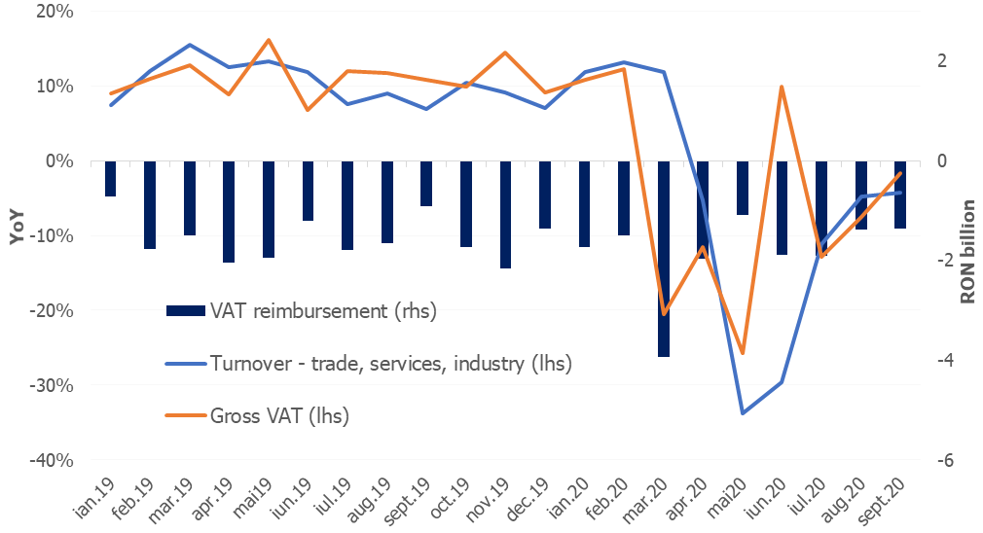

Source: MoPF, NIS, own calculations
Fig.3 VAT revenue
Excise duties receipts totalled RON 22.2 billion in the first nine months of 2020, decreasing by 3% compared to the similar period of last year.
The unfavourable dynamics is explained by a 20% contraction of excise revenue from energy products over Mar-Sep 2020, mainly due to a decline of fuel consumption under the current circumstances (limiting the consumption of certain services - tourism and increasing the incidence of home working). Conversely, excise revenue from tobacco products grew by 13% (yoy), backed by the increase in the excise level on cigarettes.

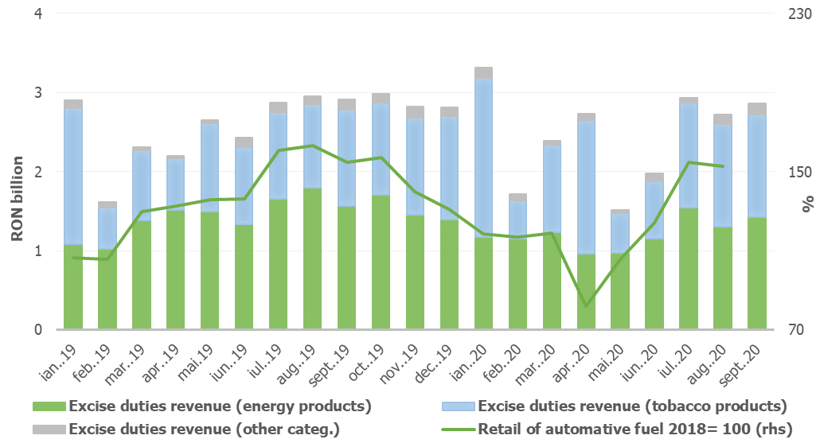
Source: MoPF, NIS, own calculations
Fig.4 Excise duties revenue
Revenue from taxes on use of goods totalled RON 2.94 billion in the first nine months of 2020. Although it recorded a significant increase compared to the corresponding period of last year, this evolution is mainly explained by a negative base effect – in 2019 there were refunded environmental car stamp duties collected over the previous years. In addition, the positive dynamics was also backed by ANCOM’s revenues collected for broadcast licenses renewal.
Conversely, revenues from gambling taxes declined by 23.6% (yoy) due to payment exemption for gambling authorizations during the state of emergency (GEO no. 48/2020) and tax deferral.
Non-tax revenues amounted to RON 20.65 billion in the first nine months of 2020, increasing by 2.2% compared to the similar period of last year. The favourable dynamics is largely explained by payments from the net revenues of the NBR (+0.6 billion RON)
EU refunds and donations totalled RON 16.04 billion in the first nine months of 2020, advancing by 44.2% (yoy).
- GENERAL GOVERNMENT EXPENDITURE

General government expenditure totalled RON 294.99 billion in the first nine months of 2020, advancing by 15.4% compared to the corresponding period of the previous year. As a percentage of GDP forecast, total expenditure increased by 3.8 pp, from 24.1% in 2019 to 27.9% in 2020. This increase is also explained by the measures adopted to limit the spread of the virus, and on the other hand, by discretionary measures adopted to mitigate the negative impact on the economic activity.
Thus, RON 4.07 billion were paid in the first nine months of 2020 for technical unemployment benefits, RON 842.49 million for other categories of professionals and for those with an individual employment agreement that were forced to stop their activity in the context of the state of emergency, RON 1.66 billion representing amounts granted to employers for the settlement of a part of the gross wage of employees retained at work (41.5%), and RON 87.8 million for allowances to parents in order to supervise their children during the temporary closure of educational institutions.
In September was registered the highest level of monthly expenditure in 2020, respectively RON 38.9 billion compared to a monthly average of RON 32.0 billion. This is explained by the fact that in September the budget expedinture also include the additional amounts of RON 1.1 billion related to the increase of the pension point by RON 177 of September 1st 2020, and a ~20% increase of child allowance as of August 1st 2020; RON 0.84 billion to compensate agricultural producers for crops affected by drought; RON 0.3 billion from the sale of greenhouse gas emission certificates for the implementation of financial measures in sectors with significant risks of carbon leakage. Furthermore, there were higher payments than the monthly average so far related to investment projects (RON 2.64 billion), goods and services, especially for medicines and health products (RON 1.0 billion), and related active measures and sick leave (RON 0.9 billion).
Compensation of employees totalled RON 80.99 billion, up by 6.5% compared to the same period of last year, reflecting public wage hikes and introduction of meal allowance to all public employees as of January 1st, 2019 (Law no. 153/2017), but also by another round of public wages hikes as of January 1st, 2020. As a percentage of GDP forecast, compensation of employees amounted to 7.7%, increasing only marginally compared to the first nine months of 2019 (+0.5pp). In addition, RON 247.5 million were paid to award bonuses to the medical staff treating Covid-19 patients.
Goods and services expenditure amounted to RON 39.61 billion, advancing by 12.7% compared to the first nine months of 2019, mainly due to additional payments for medicines, medical products and other products needed to test and treat patients infected with Coronavirus.
Furthermore, compared to the similar period of last year, a 8.1% increase was recorded at the level of the Unique National Fund of Health Insurances due to higher payments for drugs and outpatient medical services reimbursements.
Social assistance expenditure reached RON 104.01 billion, advancing by 22.9% compared to the similar period of last year. This evolution is mainly explained by a increase of the pension point as of September 1st, 2019, as well as the increase of pension point from September 1th, 2020 by RON 177 (from RON 1,265 to RON 1,442). It also reflects the increase from September 1th of the social allowance for pensioners from RON 704 to RON 800, as well as the increases of child allowance starting with May 1th, 2019, January 1th, 2020 and August 1th, 2020 (an increase by ~20% compared to July 2020).
At the same time, since April, additional payments have been made to offset the negative impact of the Coronavirus outbreak: temporary unemployment benefits (RON 4.07 billion), unemployment benefits for other categories of professionals and for those with an individual employment agreement that were forced to stop their activity due to the pandemic (RON 842.49 million), as well as amounts granted to employers for the settlement of a part of the gross wage of employees retained at work (41.5%), amounting to RON 1.66 billion. Furthermore, the sick leave reimbursements continue to be repaid at an accelerated pace in order to reduce the stock of outstanding payments (RON 3.08 billion over the first nine months of 2020, twice as much as in the same period of the previous year).
Subsidies reached RON 5.59 billion, the largest part being allocated to the agricultural and transportation sectors, i.e. subsidies to support agricultural producers, passengers’ transportation, and for price - tariff differences.
Other expenditure amounted to RON 5.6 billion, representing mainly amounts related to payment titles issued by the National Authority for Properties Restitution, scholarships for students and payments related to court decisions, as well as allowances paid to parents in order to supervise their children during the temporary closure of educational institutions (RON 87.8 million). Also, in September, state aid schemes amounting RON 842.74 million were granted to agricultural producers affected by drought.
Expenditure for projects financed from non-reimbursable external funds (including EU subsidies for agriculture) totalled RON 16.7 billion in the first nine months of 2020, up by 29.2% yoy.
Investment, which includes capital expenditure and spending related to development programs financed from domestic and external sources, amounted to RON 29.8 billion in the first nine months of 2020, up by 29.8% compared to the similar period of last year. At the same time, it is the largest amount invested in the economy in the last 10 years, exceeding the public investment related to the entire year 2016, as well as those related to 2017.
Investment dynamics in the first nine months of 2020 reflect increases at both central and local budgets, financed from both domestic and non-reimbursable external funds. Thus, the local administration invested 77.5% more than the same period last year in projects financed from non-reimbursable external funds related to the financial framework 2014-2021.
Furthermore, RON 327.5 million were paid from the budget of the Ministry of Internal Affair for the purchase of emergency medical products, including thermal scanners, in order to limit the spread of the Coronavirus.
Source: MoPF
Fig. 5 Public investment structure

Increase in average gross earnings in the economy by 6.4% and decrease in the number of employees by 0.7%.
Labour income tax receipts accounts for ~80% of total PIT revenues.
GEO no. 29/2020 until June 15, 2010, with the extension of the period until June 25, 2020 (GEO no. 90/2020), and subsequently until October 25, 2020 (GEO no. 99/2020).
August 2020 compared to August 2019.
GEO no. 30/2020, modified through GEO no. 32/2020
With a share of ~95% of total CIT receipts.
GEO no. 29/2020 until June 15, 2010, with the extension of the period until June 25, 2020 (GEO no. 90/2020), and subsequently until October 25, 2020 (GEO no. 99/2020);
Net VAT receipts = gross VAT receipts – VAT reimbursement
They have the largest share of total excise duties (approximately 57%).
GD no. 226/2020 regarding the establishment of fees due for the extension of radio frequencies licenses, and payment conditions.

